L-System Fractals

Modelling of Plant Growth

The beauty of plants has attracted the attention of mathematicians for centuries. The Bilateral symmetry of leaves, the rotational symmetry of flowers, and the helical arrangements of scales in pine cones have been studied most extensively.

The first is the elegance and relative simplicity of developmental algorithms, that is, the rules which describe plant development in time.

The developmental processes are captured using the formalism of L-systems. They were introduced in 1968 by Aristid Lindenmayer as a theoretical framework for studying the development of simple multicellular organisms, and subsequently applied to investigate higher plants and plant organs. After the incorporation of geometric features, plant models expressed using L-systems became detailed enough to allow the use of computer graphics for realistic visualization of plant structures and developmental processes.

The central concept of L-systems is that of rewriting. In general, rewriting is a technique for defining complex objects by successively replacing parts of a simple initial object using a set of rewriting rules or productions. The classic example of a graphical object defined in terms of rewriting rules is the snowflake curve (Figure below), proposed in 1905 by Koch von Koch . This construction can be described as follows:

One begins with two set of shapes, an initiator and generators. The generator is an oriented broken line made up of N equal sides of length r. Thus each stage of the construction begins with a broken line and consists in replacing each straight interval with a copy of the generator, reduced and displaced so as to have the same end points as those of the interval being replaced. Figures below show the process.
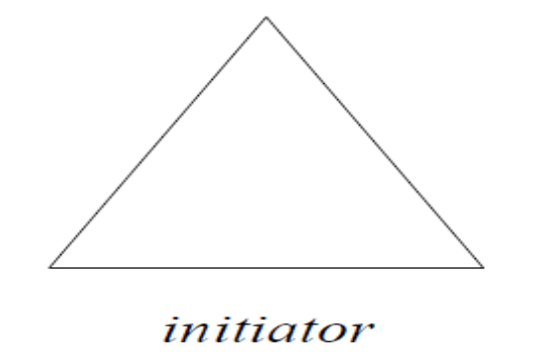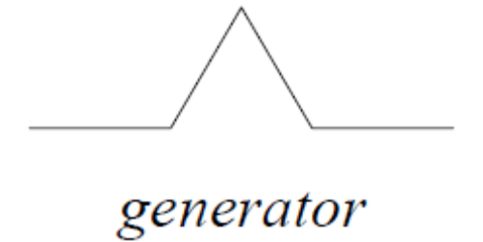
Fig 17. 1


Fig 17. 2
After 1 iteration , i.e.; n=1 n=2
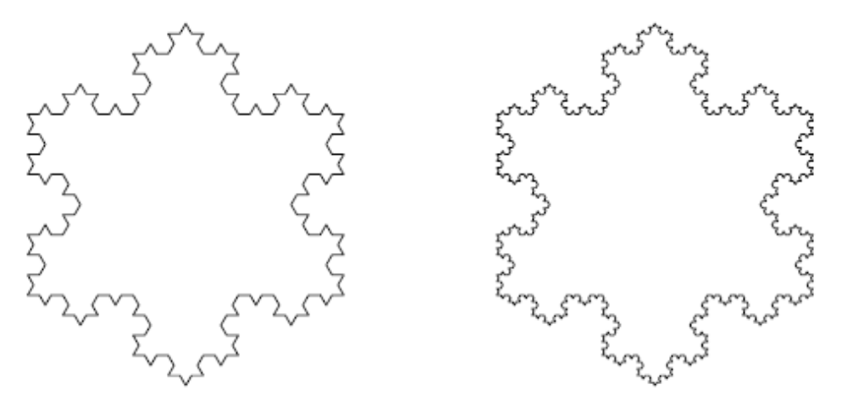
Fig 17. 3
n=3 n=4

While the Koch construction recursively replaces open polygons, rewriting systems that operate on other objects have also been investigated. The most extensively studied and the best understood rewriting systems operate on character strings.
To give an example, the single rule: a → b a b transforms the string: a b a c into b a b b b a b c

Prusinkiewicz in 1970s gave geometrical interpretation to the generated letters based on a LOGO-style turtle ( A computer based graph drawing system in which the cursor is called a turtle and instruction to move the turtle in different direction is given by a set of different keys on keyboard) and presented several examples of fractals and plant-like structures using L-systems

The basic idea of turtle interpretation is given below. A state of the turtle is defined as a triplet (x, y, α), where the Cartesian coordinates (x, y) represent the turtle’s position, and the angle α, called the heading, is interpreted as the direction in which the turtle is facing.
Given the step size d and the angle increment δ, the turtle can respond to commands represented by the following symbols

F : Move forward a step of length d. The state of the turtle changes to (x’, y’,
α), where x’ = x + d cos α and y’ = y + d sin α. A line segment between
points (x, y) and (x’, y’) is drawn.

f : Move forward a step of length d without drawing a line.

+ : Turn left by angle δ. The next state of the turtle is (x, y, α+δ). The positive
orientation of angles is counter clockwise.

−: Turn right by angle δ. The next state of the turtle is (x, y, α − δ).

Given a string ν = FFF-FF-F-F+F+FF-F-FFF, the initial state of the turtle (x₀, y₀, α₀=90) and fixed Interpretation parameters d (=1 unit) and δ(=90degree), the turtle interpretation of ν is the figure (set of lines) drawn by the turtle in response to the string ν .

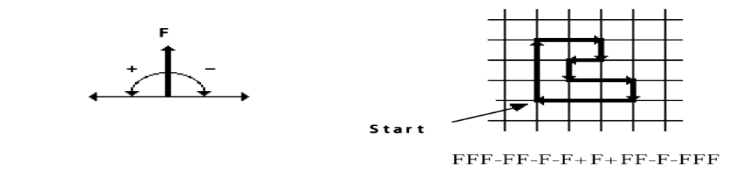
Specifically, this method can be applied to interpret strings which are generated by L-systems. For example, Figure below presents four approximations of the 8 segment quadratic Koch curve.

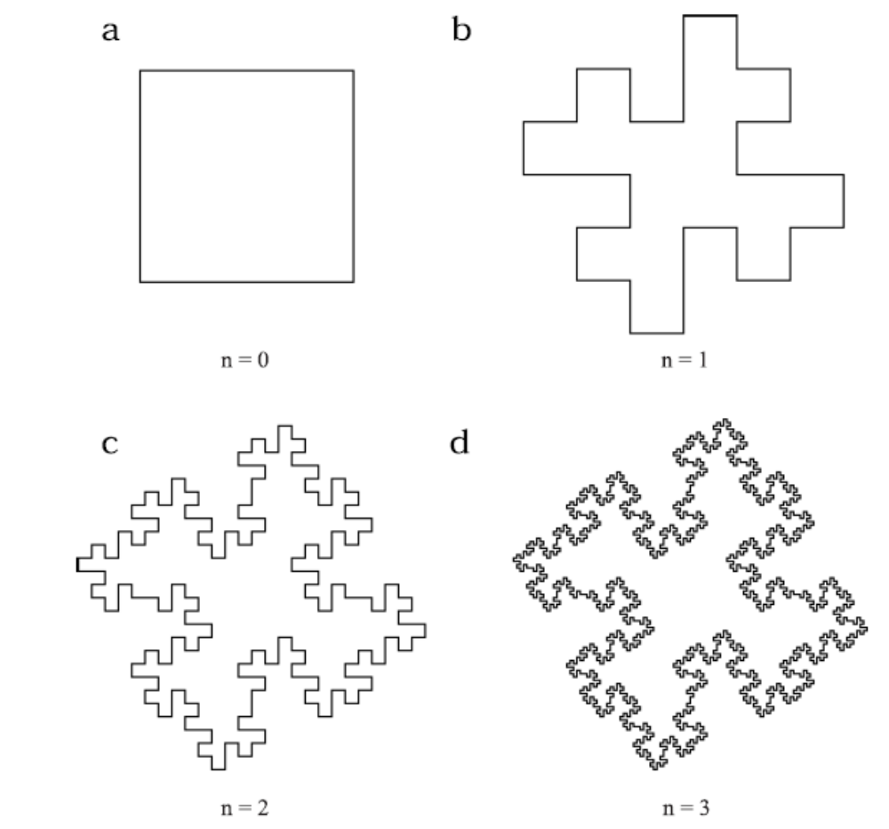

These figures were obtained by interpreting strings generated by the following L-system:

Initiator ω : F − F − F − F
Generator p : F → F − F + F + FF − F − F + F

The images correspond to the strings obtained in derivations of length 0 to 3. The angle increment δ is equal to 90°. The step length F is decreased four times between subsequent images, making the distance between the endpoints of the successor polygon equal to the length of the predecessor segment.

This step length reduction is usually given as a parameter.

Branching structures and Bracketed OL-systems

Plant kingdom is dominated by branching structures. For this , an extension of turtle interpretation to strings with brackets was introduced. They are interpreted by the turtle as follows:

[ Push the current state of the turtle onto a pushdown stack. The information
saved on the stack contains the turtle’s position and orientation, and possibly
other attributes such as the color and width of lines being drawn.

] Pop a state from the stack and make it the current state of the turtle. No line
is drawn, although in general the position of the turtle changes.

Example 1. We want to design a L-system, which will generate a simple branched structure: Following are the Axiom(initiator) and Rules (also known as productions rules) for rewriting

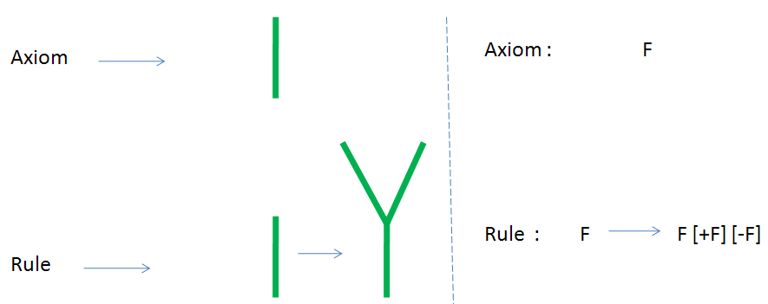

With a use of the rule we obtain an order of strings:
0. step: F
1. step: F[+F][-F]
2. step: F[+F][-F][+F[+F][-F]][-F[+F][-F]]
etc.
After the visualization a plant created by this L-system after 6 steps looks like bush
Note that step length is constant for every iteration

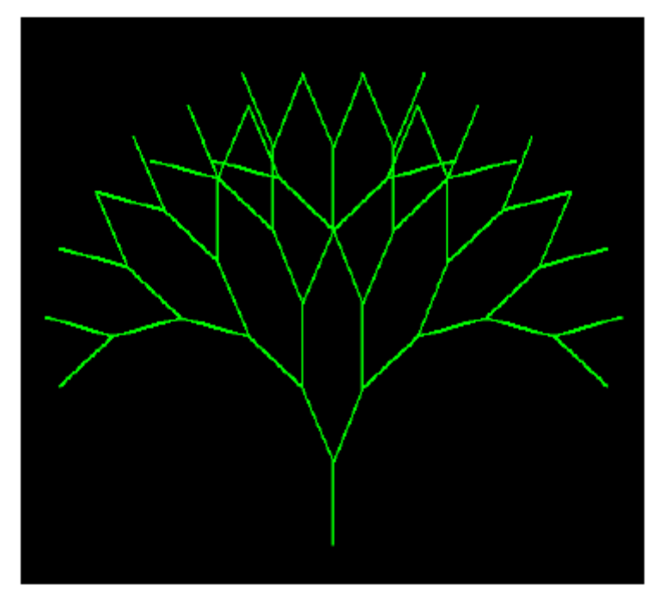

Example 2.

During the growth of the tree we want certain part of the tree to remain in same length and other part to grow. This can be modeled by two rules as given below.
axiom: X
p1: X → F-[+X]+F[-X]+X
p2: F → FF

If we assume step length d is replaced by d/2 after each iteration , then the rule
F → FF ensures that the F part of the tree in any iteration remain there in the subsequent stages without any further growth.

Representation of a plant after 5 steps of derivation is on the picture below . A model of plant is more realistic than on the picture. The turning angle is 22.5°. This kind of branching is characteristic for apple tree

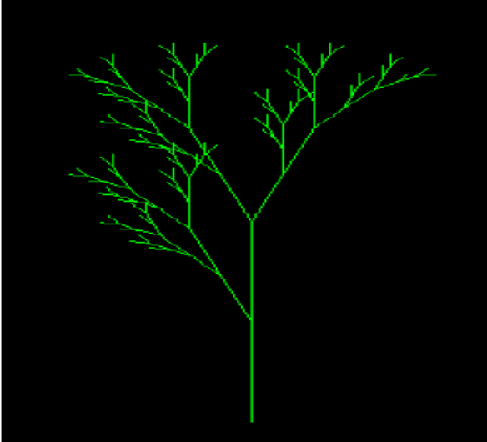

Example 3

Axiom X ; P1 :
X → F[+X][-X]FX ;
P2 : F → FF;
divisor = 2.0; angle = 27.9
After 9 iteration the figure is



Following are the some of the trees and their respective axiom and rules.
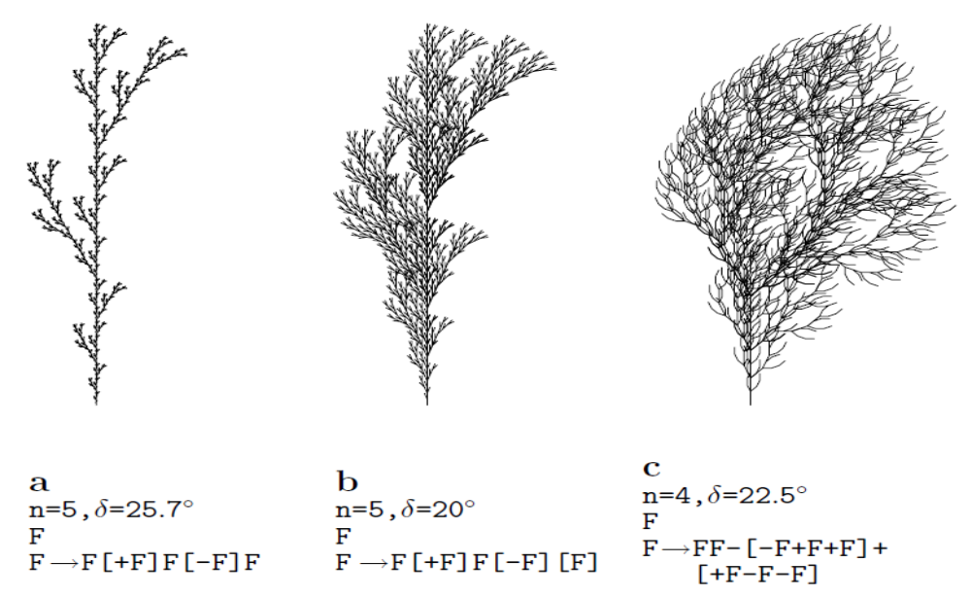

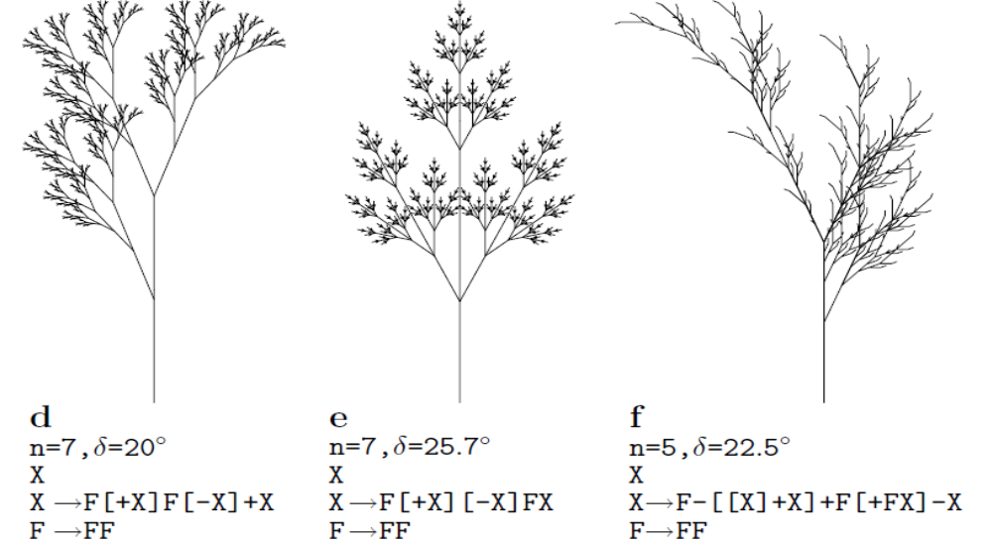

Lsystem concept can be easily extended to 3D. readers may refer references for more details.

A 3D L-system tree

Modern applications : In Game

Related research work on L-systems application which involved modelling building and cities are done by Parish and Müller (2001) procedurally using extended L-systems to build street maps and city buildings

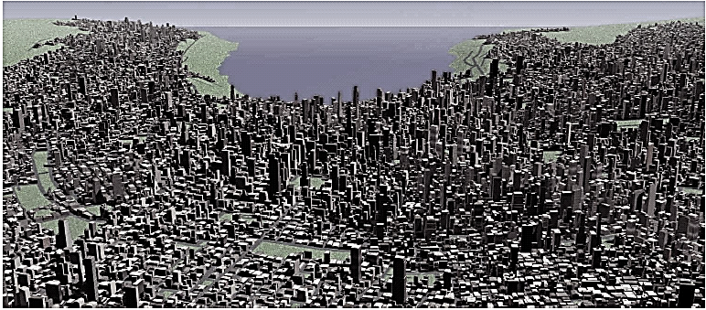

This is useful for urban modelling and planning environment but this work lacks support for real time interactively to generate flyby those city buildings scenery.
However, this problem has been approached and refined by G. Stefan, P. Jeremy, S. Nigel and L.Geoff (2003). They proposed methods using view frustum filling, pseudo random number generator and cached display lists to display a ‘pseudo infinite’ virtual cities in real-time to the user.

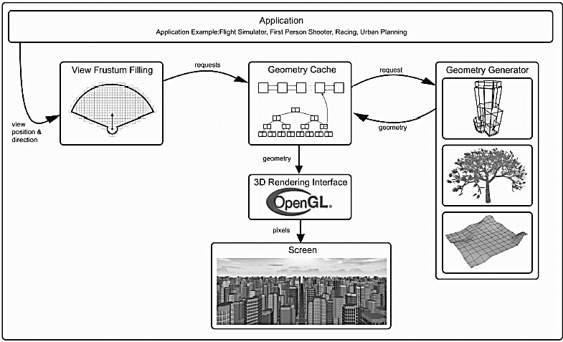

Implementation
The implementation of Lsystem fractals in Excel takes quite some creative thinking to achive. Implementation of certain strainght forward type like Koch, Peano curves are comparatively simpler. Retracing types like trees takes real twisted thinking to implement.
Before going to the implementation of Lsystems in Excel, let us have a lok at some features and difficulties we are going to meet with when we think of Lsystems in Excel
- Size limit in cells is going to be a major difficultywhen thinking of higher levels of Lsystems. There is a limit in Excel in the maximum size of data in a cell. For Excel 2010, it is around 100000. It may be low for the older versions. There is only one way to tackle this – break the string to parts. Have a look at Lsystem Tree 5 worksheet and you can find the string broken to 4 parts for Level5 and then handled.
- Data point limitation for graph plotting is another hampering factor. Luckily Excel 2010 is not having such a difficulty. Excel 2007 has a limit of 32000. Giving breaks in the data points is one solution, or else the data points may have to be entered as separate series.
- Different Lsystems having varying implementation is another feature of Lsystem implementation in Excel. For some, ‘D’ alone is present as movement parameters and for others we have ‘d’, ‘X’ etc.This is not a problem except that the implementation in the formulae may slightly vary. For example, the implementation of a Koch snowflake does not need breaks in between as it contains only ‘D’, ‘+’ and ‘-‘. Whereas a tree implementation requires gaps in the data point set for effective retracing in the graph, which is explained in the next feature
- Retracing requires spacing in the graph series. This is another major feature for Lsystems. When ‘[‘ and ‘]’ are encountered, it points to a retracing operation. We require a stack for this operation, which is a moving part and requires macro help to implement (which is what we thought earlier!)
As far as possible we shall include all the implementation variations by handling various cases in the following chapters.
Roger T Stevens describes several notations in his textbook ‘Creating Fractals’ which we are including below. The parameters for most of the fractals described and implemented in this textbook is taken from his textbook.
Some notations which we shall be using are
d – step without drawing line
D – step with drawing line
L – Left pattern
R – Right pattern
X - X pattern
S – Space or blank. No operation is defined for this except for breaks in graphs. We introduced this for plotting purpose.
+ - Turn clockwise by Angle1
- - Turn anticlockwise by Angle1
* - Turn clockwise by angle2
# - Turn anticlockwise by angle2
[ - store current position and direction
] – go back to the stored position and direction

There are much more combinations and fractals using many more symbols and most of them can be created with some innovative thinking applied.
However, the generation of L systems may not be possible in Excel with the exact mathematical way as defines, but with some additional changes applied which does not alter the original fractal obtained. Certain levels are also skipped in the Workbooks, which would have become repetitions in every workbook. Wherever Level 1 is trivial, we have skipped it and considered Level2 as Level1 for convenience. Kindly bear with us in this.

The workbooks looks like Fig below in Sheet1 and all of them are available in the path ‘Fractals/Workbooks/Lsystem/’. To work on, select the unexpanded ones and generate the curves. You can compare them with the expanded ones to see whether the result is correct. Unexpanded ones are better to make changes and play around to apply your innovations and ideas, because it takes only less time to calculate the changes in your system.
Lsystems have their initiators defined and plotting them makes Level1 in other textbooks. Successive levels starts with the symbols replaced with defined Lgenerator strings. Angle 1 and 2 applies according to real coordinate system. We have tried to keep the coordinate system as far same as your daily graph works, so that you feel at home when doing the experiments. In other plotting systems, Lsystem is drawn using turtle graphics which is a much easier way to draw Lsystems. We follow a more coordinate system based approach to plot the fractal. At each point we calculate the coordinates and adjust at various locations for good plotting with Excel.
Divisor is used for Line length for pattern drawing. For each level, the length reduced by the divisor factor

